1. **Create a database named as OLYMPICS-**

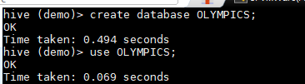

1. **CREATE a TABLE named OLYMPIC inside the database OLYMPICS with below columns**
2. **LOAD DATA from LOCAL File system to the table OLYMPIC**

**Contents are also shown below after loading the table-**

